My Answers

# Task One

### Best Design Patterns to Implement it:

* Builder Design Pattern
* Singleton Design Pattern
* Observer Design Pattern

### Explain why you chose these Design Patterns

* I chose Singleton design pattern because it has a single class which is responsible to create an object from class while making sure that only single object can be created from that class where making sure that one user is responsible for using the system and track its activities.
* **I chose Builder design pattern because it**  is a creational design pattern where it lets you construct complex objects step by step and allows you to produce different types and representations of an object using the same construction code and finally, it’s used to create new user using one interface represent its attributes and role and permission.
* **I chose Observer design pattern because it notifies all the employee in one department when doing meeting or any other announcement by the manger or the head of department.**

### ****Is there an alternative for any of them?****

* **For Singleton design pattern (No) because it’s the only design pattern in which you can create an object while making sure that only single object gets created.**
* **For Builder design pattern (Yes) because the Factory design pattern can be used too where it lets you create object without exposing the creation logic to the client and refer to newly created object using a common interface, just an implementation difference.**
* **For Observer design pattern (No) because if a new meeting or big announcement is released (where change happen), we want all the related employees to get notified and no other design pattern can do the job better.**

### ****Why did you choose the one you chose?!****

* **I chose the Builder design pattern over Factory design pattern because to create instance of user class we might need to slowly build up the parameter list which could take more methods to invoke before we build the final object on the other hand factory method pattern requires the entire object to be built in a single method call.**

### ****Class Diagram****

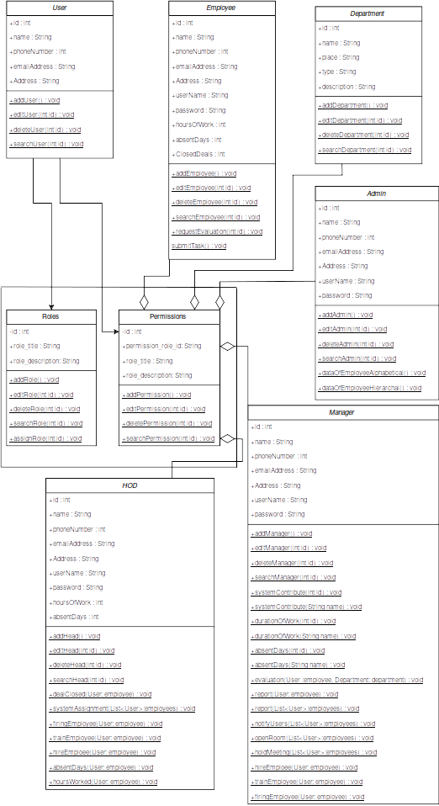

# ****Task Two****

### Answers on GitHub:

* **https://github.com/Mostafa-Bkry/Interview-questions-problem-solving-in-c-.git**

### ****Given a string, write a function to check if it is a permutation of a palindrome. A palindrome is a word or phrase that is the same forwards and backwards. A permutation is a rearrangement of letters. The palindrome does not need to be limited to just dictionary words.****

* **Example: Input: Tactcoa**
* **Output: True (permutations: "tacocat", "atcoeta", etc.)**
* **Answer**

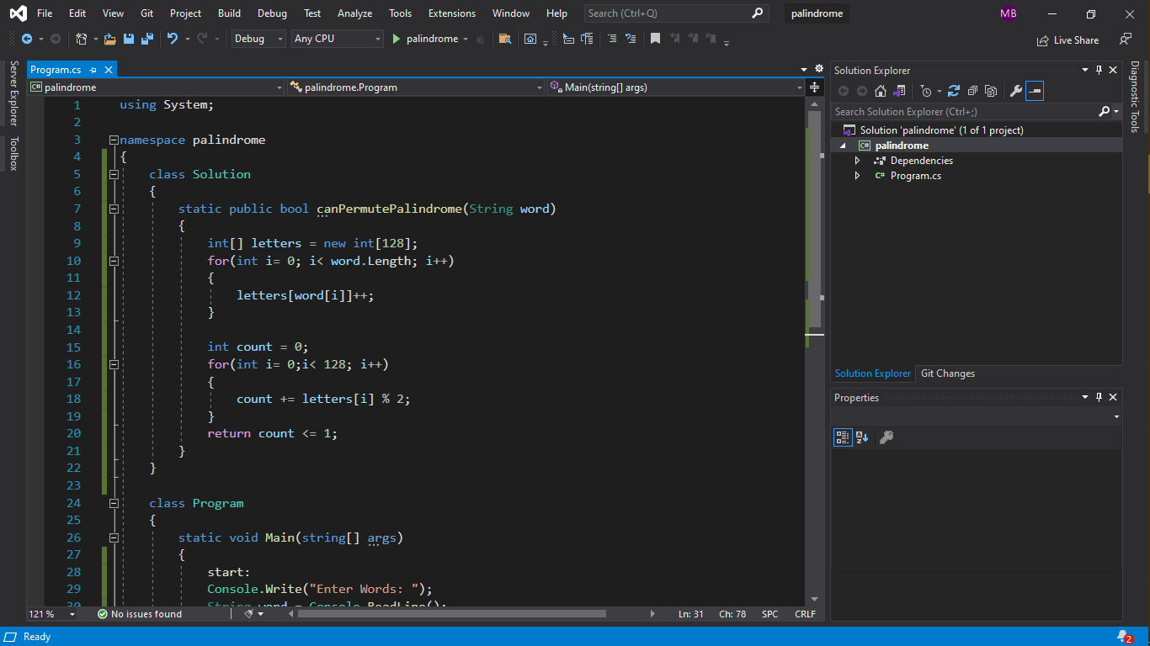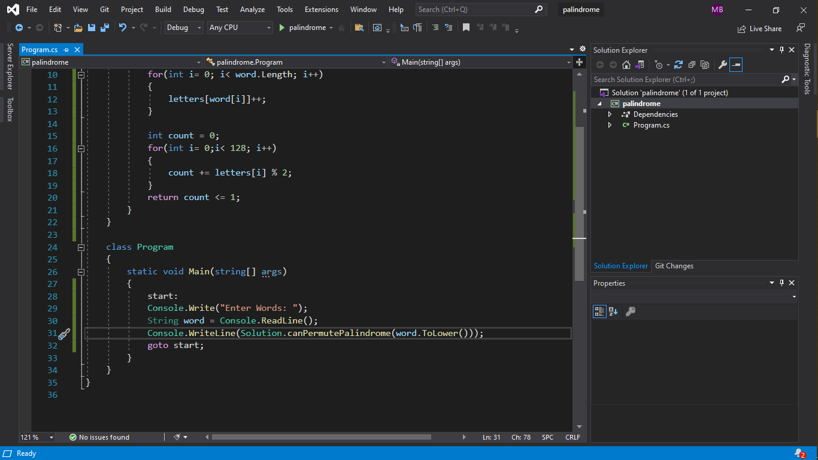

### ****Write an algorithm such that if an element in an MxN matrix is 0, its entire row and column are set to 0****

* **Answer**

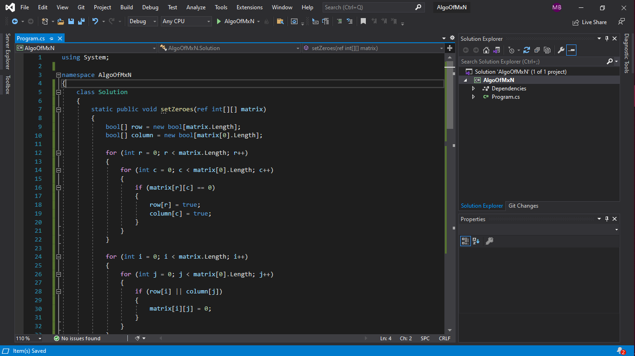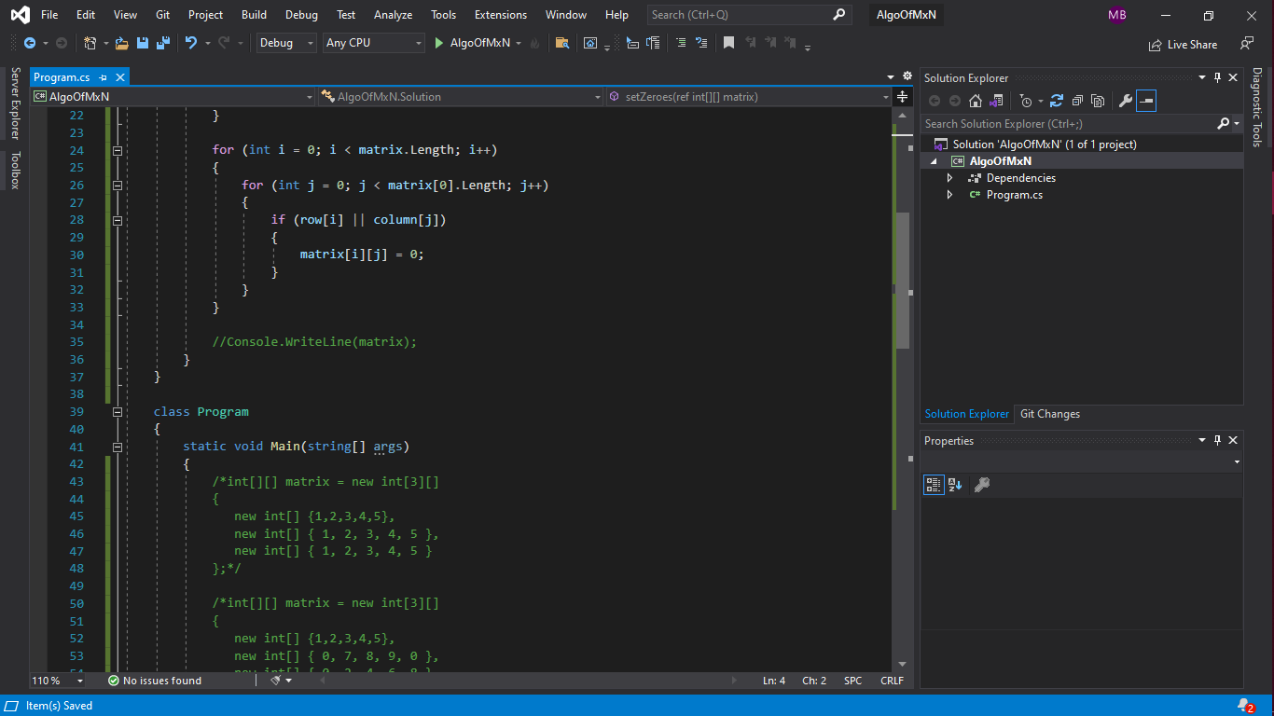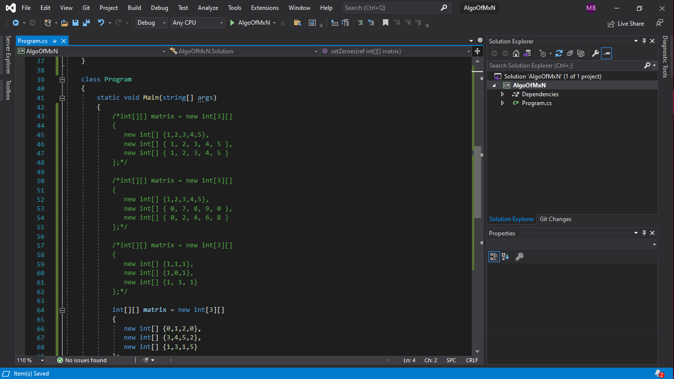

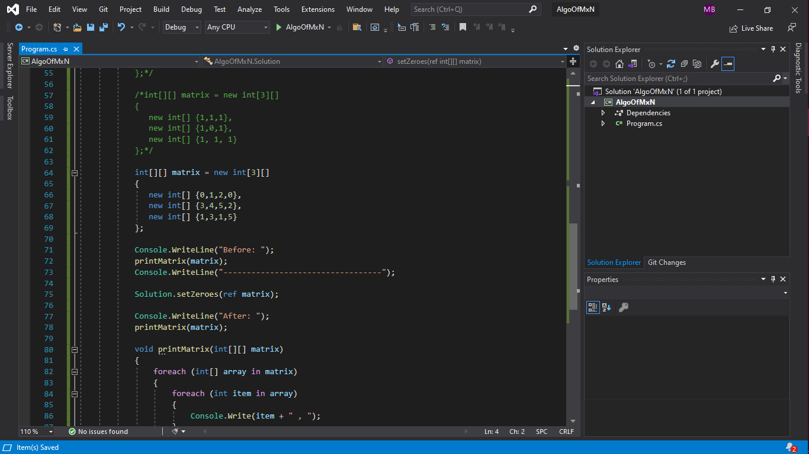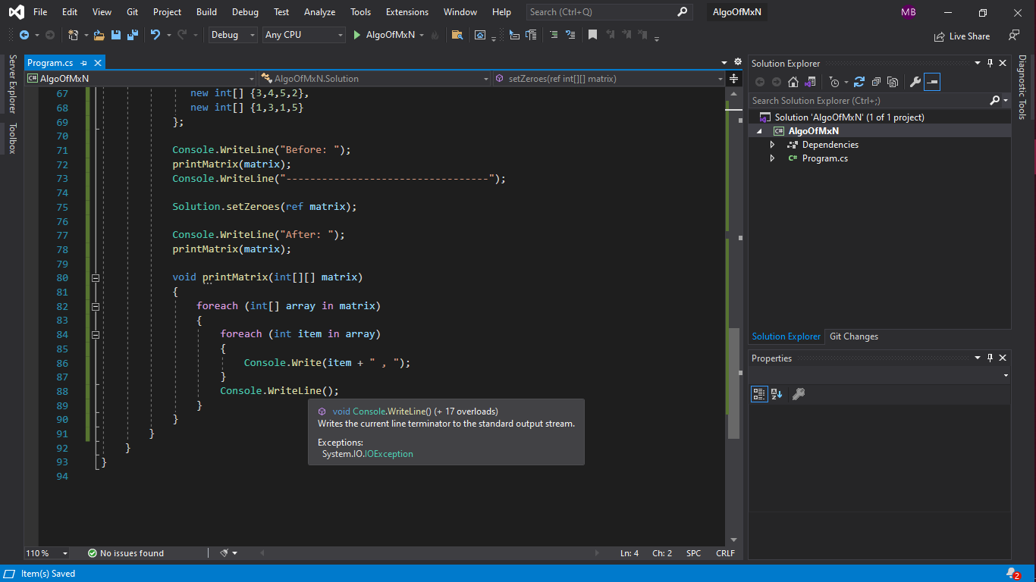

### A child is running up a staircase with n steps and can hop either 1 step, 2 steps, or 3 steps at a time. Implement a method to count how many possible ways the child can run up the stairs.

* **Answer**

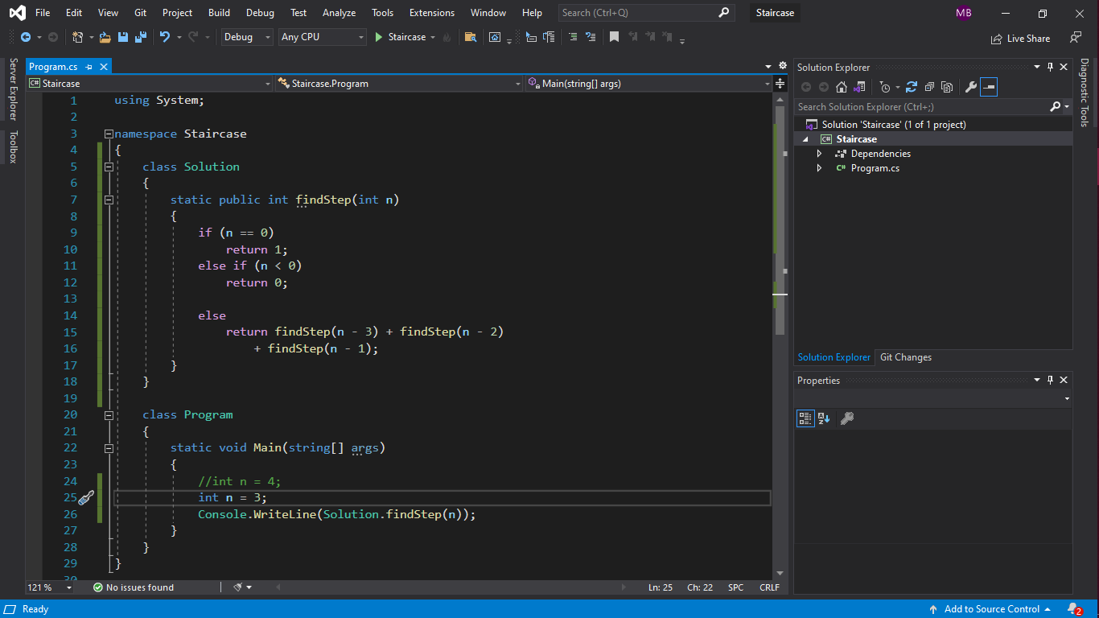

### Write a method to compute all permutations of a string of unique characters.

* **Answer**

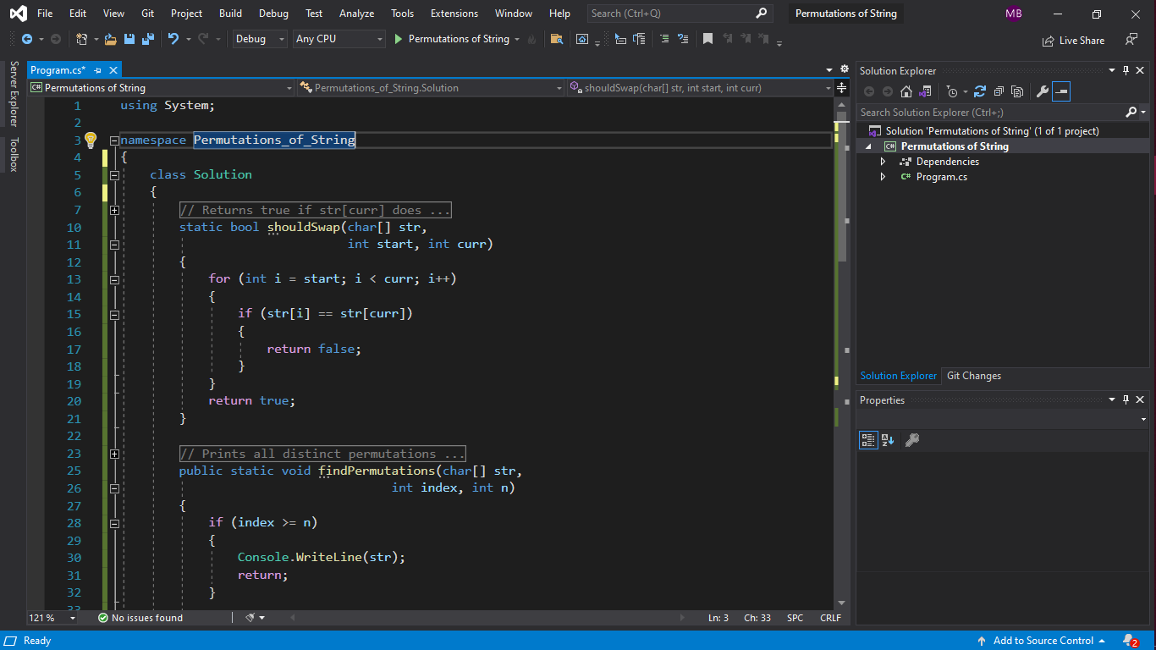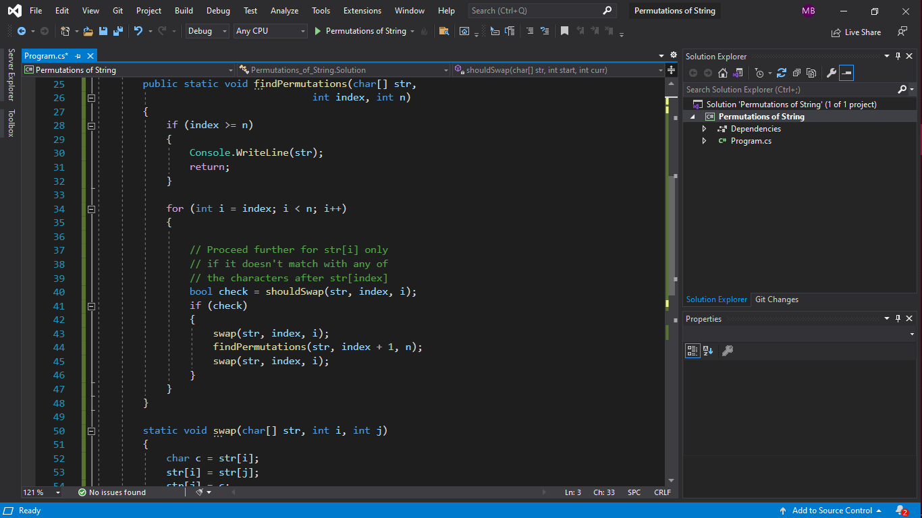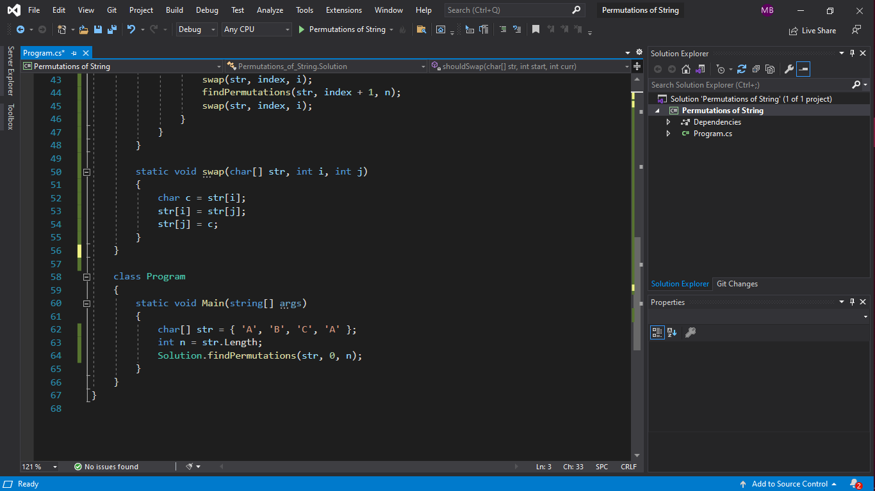

### ****In an array of integers, a "peak" is an element which is greater than or equal to the adjacent integers and a "valley" is an element which is less than or equal to the adjacent integers.****

* **Answer**

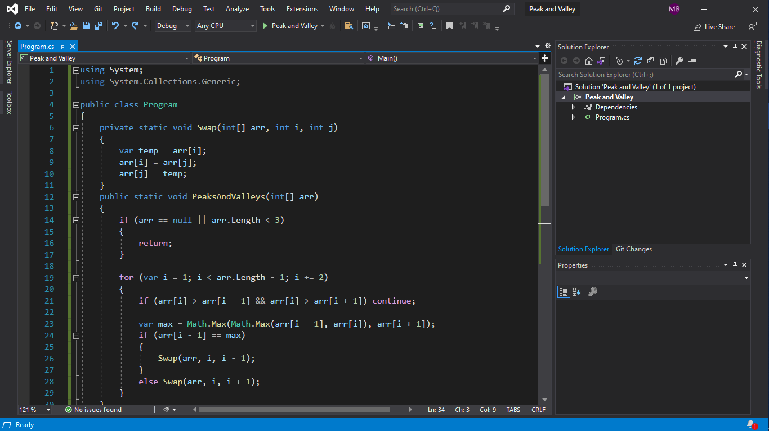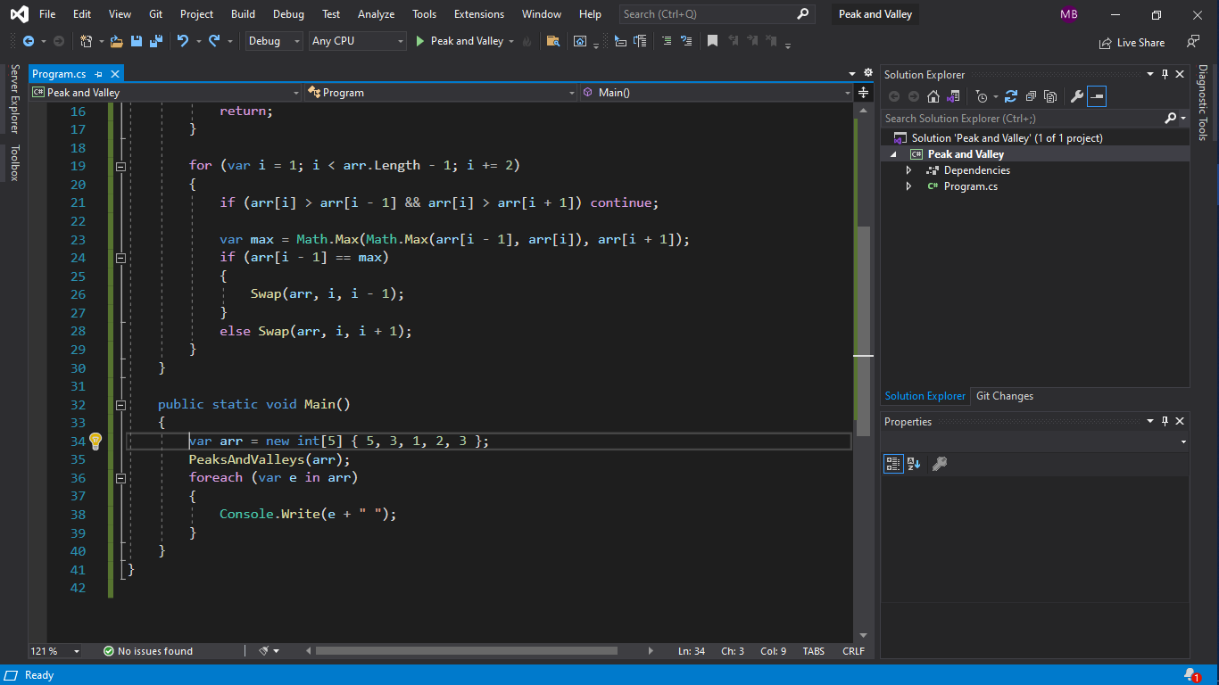

# ****Task Three****

### ****You have 20 bottles of pills, where every bottle has a huge number of pills. 19 bottles have 1.0-gram pills, but one bottle has pills of weight of 1.5 grams. Given a scale that provides as exact measurement, how would you find the heavy bottle? You can only use the scale once.****

* **Answer**

We know the “expected” weight of a bunch of pills. The difference between the expected weight and the actual weight will indicate which bottle contributed the heavier pills, provided we select a different number of pills from each bottle.

We can generalize this to the full solution: take one pill from Bottle #1, two pills from Bottle #2, three pills from Bottle #3, and so on. Weigh this mix of pills. If all pills were one gram each, the scale would read 210 grams (1 + 2 + • • • + 20 = 20 * 21 / 2 = 210). Any “overage” must come from the extra 0.1 gram pills.

This formula will tell you the bottle number: (weight- 210 grams)/0.1 grams.

**So, if the set of pills weighed 216.5 grams, then Bottle #13 would have the heavy pills.**

### ****There are three ants on different vertices of a triangle. What is the probability of collision (between any two or all of them) if they start walking on the sides of the triangle? Assume that each ant randomly picks a direction, with either direction being equally likely to be chosen, and they walk at the same speed. Similarly, find the probability of collision with n ants in an n-vertex polygon.****

* **Answer**

Since every ant has two choices (pick either of two edges going through the corner on which ant is initially sitting), there are total 2 power 3 =8 possibilities.

Out of 8 possibilities, only 2 don’t cause collision. So, the probability of collision is 6/8 and the probability of non-collision is 2/8.

1. The probability of collision = 6 / 8 = 3 / 4 = 0.75
2. **The probability of non-collision =** 2 / 8 = 1 / 4 = 0.25

### **You have There are 100 closed lockers in a hallway. A man begins by opening all 100 lockers. Next, he closes every second locker. Then, on his third pass, he toggles every third locker (closes it if it is open or opens it if it is closed). This process continues for 100 passes, such that on each pass i, the man toggles every ith locker. After his 100th pass in the hallway, in which he toggles only locker #100, how many lockers are open?**

* **Answer**
  + In the second pass all even lockers are closed and all odd lockers are opened.
  + In the third pass half of even lockers are opened and half closed, and half of odd lockers are opened and half closed.
  + In the fourth pass half of opened even lockers are closed.
  + Then, we found that the only way a locker could be left open is if it is toggled an odd number of times.
  + The only numbers with an odd number of factors are the perfect squares.
  + So, the perfect squares are left open ( 1, 4, 9, 16, 25, 36, 49, 64, 81, 100 ).
  + **Finally, we found that there are 10 lockers are left open.**